PROMOTIONAL MATERIALS

Training materials | Version 2  5 2019

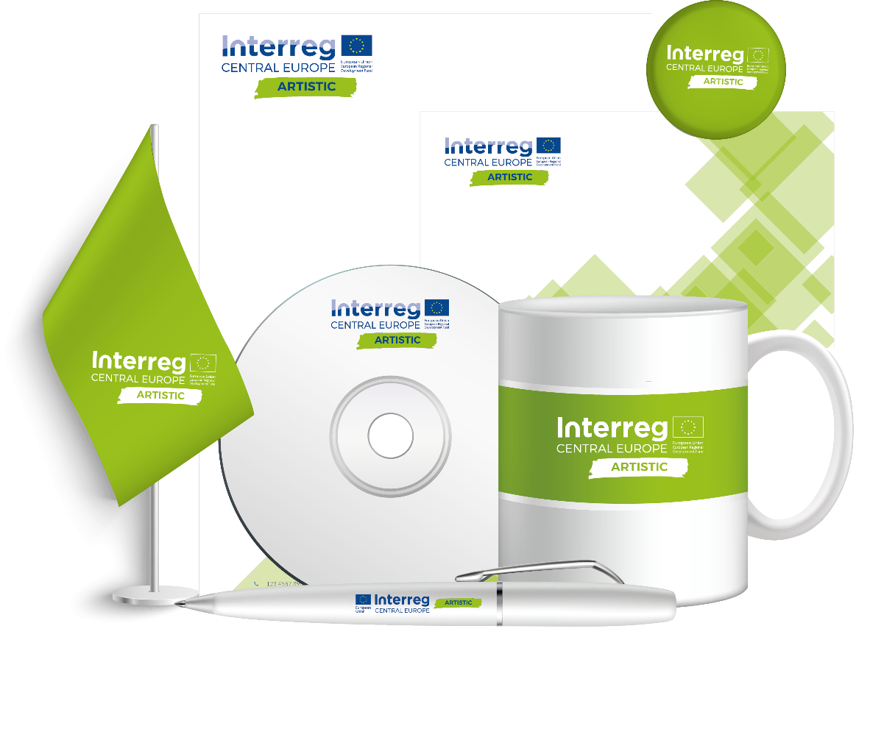

Table of Contents

Introduction 3
A. Basic information 4
1. Types of printed promotional materials 4
2. Logo 11
3. Graphics from the Internet 13
4. Summary 18
B. Further information 19
5. Cooperation with a graphic designer 19
6. Types of graphics and file formats 23
7. Colours 27
8. Fonts 30
9. Bibliography 34

Introduction
Contemporary culture is often said to be a so-called image culture, which means that its main medium that transmits content is the image. Although such a statement is very general, which makes it easy to discuss and disagree with it, the statement that images constitute an attractive complement to a text is not so controversial anymore. Graphics allow presentation of certain ideas in an accessible way, artistically depict a problem and show it in an effective form. Therefore, it is worth ensuring that the message we are building uses various forms that will be complementary to each other and thus more effective.
Most of us are able to intuitively say whether we like or dislike a particular image, photo or graphic (and often it will be an accurate aesthetic impression). However, it is much harder to analyse the visual message and answer the question: why do you (not) like it? This is one of the reasons why it is worth having a general idea about the basics of graphic design - it will help us to work with graphic designers and prevent acceptance of material that is burdened with basic and glaring technical errors. The ability to analyse and evaluate visual messages is a capability that will certainly make life easier for any person who has any contact with promotion or marketing communication.

- Basic information
- Types of printed promotional materials
Although promotion on the Internet is constantly expanding, it is still worth remembering about advertising through other media carriers. In fact, the best results (using fashionable vocabulary: synergy effects) are achieved by using both of these marketing communication channels. In this chapter, however, we will focus on printed promotional materials, the most important of which include:
- Business cards,
- Leaflets,
- Posters,
- Billboards,
- Roll-up banners,
- Promotional gadgets.

  - Business cards
The main role of a business card is to provide the most important contact information in an accessible and elegant form. In addition to the information function, it also has advantages for promotion (logo display) and image creation. A good business card should be characterized by elegance, simplicity and transparency. Although there is no way to present a single golden rule for creating business cards, it is possible to try to formulate some general rules (which may sometimes be broken to serve a different concept).
"The field containing the logo, company name / name and surname is traditionally placed in the centre or upper part of the business card, on the left (in the case of a one-sided business card or on the reverse of a two-sided business card). We can distinguish them using a larger or bold font. Contact information is usually placed in the lower part - centrally or in the lower right corner. It is worth including additional information on business cards - next to the name and surname - the professional title, e.g. MEng, MArch, DrMedVet, Dr, Professor or military rank. Under the name and surname, we can add information about the position".
Of course, as we mentioned, these rules can be broken. However, this should be done consciously and creatively to achieve the best results. A slightly less standard, but still attractive and well-composed, business card is shown in Figure 1.

Figure 1. Example of a personal business card
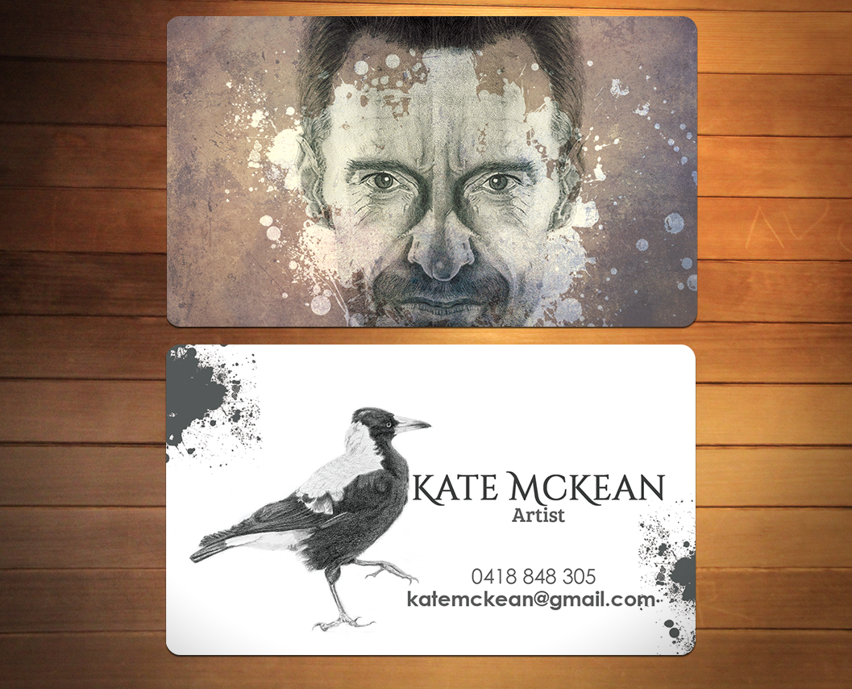
Source: https://businesscard.designcrowd.com/contest/2384174
A business card designed in this way fulfils the most important functions - it provides information and builds an image. In the case of people dealing with culture, it is necessary to break away from the usual patterns that work in the field of visual business communication. An artist must be creative, which can be demonstrated precisely through the original aesthetics of a business card. However, you need to be show skilful restraint so as not to create too complicated a design. Even in the case of the unconventional business card shown in Figure 1, it should be noted that its front contains not only the most important information, but in terms of aesthetics, it primarily focuses on minimalism.

  - Leaflets
These are small promotional materials, used for quick distribution in public places, usually directly to the recipients. It is a medium that allows the inclusion of the most important information on a selected topic, such as an upcoming cultural event.
Thinking about the preparation (or order preparation) of a leaflet, we must first determine its size - the optimal solution is the so-called DL size, which is 1/3 of the A4 format. The DL size fits easily in the hand and is longer than the A6 format, allowing you to fit in more information. Larger formats are rather inconvenient, especially A4, which can even be considered a small poster. However, this is only a theory, because in the case of leaflets there is another solution, namely folding. That is why, for example, leaflets in A4 format are often designed and printed, and then folded twice to obtain the size of a DL leaflet.
Figure 2. Standard leaflet sizes
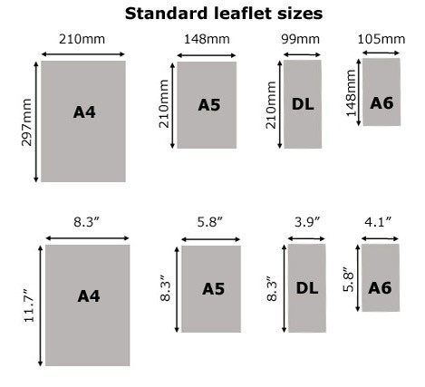
Source: https://www.letterboxdistribution.com/the-power-of-paper/
Foldable leaflets allow the obtaining of a larger print area, which after appropriate folds will still be convenient and easy to hand out. Leaflets of this type may also have aesthetic value and promote transparency by clearly introducing the sectioning of the sheet.

Figure 3. Types of folded leaflets
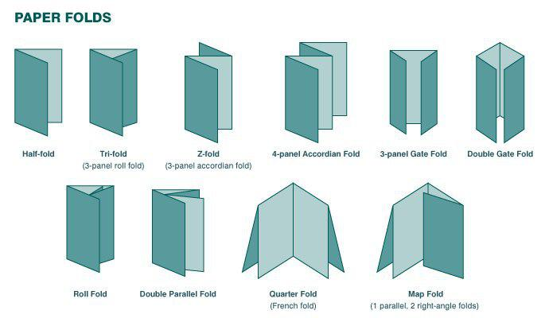
Source: https://www.letterboxdistribution.com/the-power-of-paper/

  - Posters
The poster is an excellent form of promotion used largely to inform about events that are to take place in the near future. It is therefore one of the basic promotional materials that is used in the area of intangible culture, through which information can be provided about an upcoming concert or performance. Although it does not go directly to the recipient, as in the case of a leaflet, due to its larger format it can be an effective form of communication, especially if appropriate places such as notice boards or public transport are selected for its exhibition. When designing a poster, however, a few rules should be remembered:
"First of all, the poster should not contain too much information. Most importantly, it should arouse in the recipient curiosity and interest. In some situations it will be more suggestive to use only graphics, and in others to use a small amount of text. For example, if we want to promote an event, only information about the place and time and a link to the website may be found on the poster.
(...) let's put a simple message, which will be clear to the recipient and draw his attention, this will induce him to stop for a longer time. A poster in which visual and informational chaos reigns will not fulfil its function, on the contrary - it may discourage or even put the off viewer".

A well-designed poster is able to not only stand out from the crowd of other such materials, but also transmit the most important information in a visual way, thanks to which it can be read even from a greater distance. A good example here is the poster presented in Figure 4.
Figure 4. An example of an aesthetically designed poster
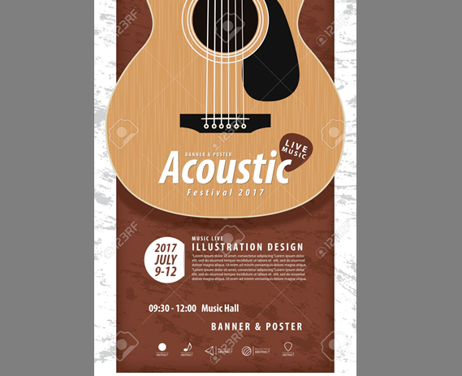
Source: https://es.123rf.com/photo_61469363_guitarra-estilo-realista-dise%C3%B1o-del-instrumento-musical-y-la-m%C3%BAsica-del-cartel-a4-dise%C3%B1o-festival-para-vector-.html
Thanks to the graphical inclusion of part of an acoustic guitar in the poster, the recipient can easily guess what the main message of the promotional material is. This is very important, because if he is interested in acoustic music, there is a high probability that he will become interested in the detailed content. It is also worth paying attention to the fact that the most important information – i.e. the date and place of the event - are easy to find. A poster designed in such a way has a chance to draw the attention of the recipient and deliver a message about the cultural initiative we are organising.

  - Billboards
A billboard, due to its price, is intended to promote large and spectacular events. However, you cannot assume that in the future there will be no opportunity to work on initiatives that will have a large promotional budget. That is why it is worth being aware of how, when and why to run a billboard campaign:
"Billboard advertising has its own rules. Due to its size, co-creation of the public space and repeatability of the message, the content and form of the advertisement should be carefully planned. Remember that an investment in billboard (or generally - large format) advertising is not the cheapest, but the rate of return and the ability to reach thousands of potential customers makes this medium one of the most attractive for advertisers.
(...) Try to put a short, catchy slogan in your advertisement. This is, after all, one of the most often associated elements, which may be an asset even long after the end of the billboard campaign. The dream of every copywriter is to create a slogan that will naturally come into everyday use - who knows, maybe this unusual artform will succeed for you.
Take care of consistency with other promotional materials - the billboard is supposed to help you, to complement the message and not destroy the current promotional achievements. Try to use your slogan in other advertising materials, so that the potential recipient always knows whose advertisement it is.
Avoid excessive colours and use of aggressive, florescent colours".
Figure 5. Example of an eye-catching minimalist billboard
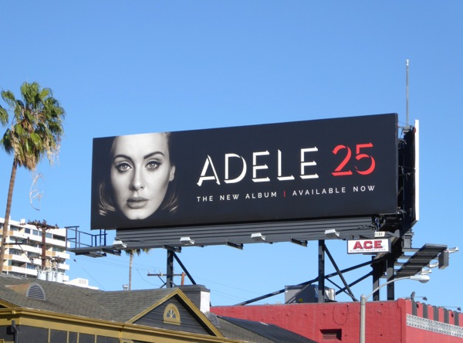
Source: https://www.canva.com/learn/billboard-advertising/
Because of its form, the billboard immediately raises the status of the transmitted content - it is large and expensive, so the event that it is advertising is probably equally important. It is also a chance to provide information in a place where cultural content does not usually appear, so it is easier to stand out among business-dominated messages. And that is why it is worth remembering about this outdoor advertisement when organizing big events.

  - Roll-up banners
A roll-up banner is a kind of portable advertising, a stand that allows you to present a graphic board. It is a good support for other promotional activities, it can build an image, and above all it is a solution that allows the exhibition of attractive graphic material in various circumstances, such as cultural events. In order to ensure that the roll-up banner message reaches the recipient as effectively as possible, it is important to remember several principles when designing it:
- Compactness – a roll-up banner is not used to present detailed ideas, but to provide basic information. Nobody will stand in front of it and study its content, so the recipient should find out the most important things from it almost at first glance.
- A catchy slogan - an indispensable element of any promotional material. The slogan must draw attention, convey the most important content and emotions, and at the same time not be too complex. Creating a good slogan is a real art.
- Readability - the font should not only be easy to take in, but also have the right size so that it is possible to read the contents of the roll-up banner even from a short distance away.
- Important information at eye level - the roll-up banner format promotes the exposure of the most important content at the optimum height for the recipient and this positive asset should be used!
- Contact details - in order not to leave the recipient with a roll-up banner that does not refer to anything specific, it is worth adding contact details to it (e-mail address, telephone number, website address, etc.). This data can be given at the bottom of the roll-up banner.
- High quality graphics - care should be taken to ensure that the materials used are of the highest quality. A roll-up banner is a large medium that is viewed from a relatively close distance (as opposed to, for example, a billboard), therefore all lower quality graphics on it will be seen as clear as day.
When thinking about buying a roll-up banner, it is important to remember - in addition to the above principles regarding design issues - that it is a rather expensive, but reusable medium. It will not be profitable as a promotion of a single workshop, concert or performance, but it can be used in the case of a whole cycle organized under a common slogan in the longer term (e.g. a year or two). The safest financial option is to buy a roll-up banner for cultural institutions that can be used during various events, thanks to which we will build awareness of our centre among potential recipients.

  - Promotional gadgets
Speaking of promotional materials, it is worth thinking about other places that can give the recipient good associations with us and ensure the display of our logo, i.e. promotional gadgets. These include:
- T-Shirts,
- Cups,
- Pens,
- Key fobs.
We should make sure that the gadgets we offer are aesthetic and functional, so that they will be willingly used in everyday life. A good example of such a gadget is presented in Figure 6. It is a nicely made figurine of a robot known from the Star Wars series of movies, which is also a power bank. Thanks to such an arrangement, it provides the recipient not only with collector's value, but also with a practical benefit.
Figure 6. Power bank in the form of one of the robots known from the Star Wars movies
Source: https://www.thinkgeek.com/product/11f0/
Promotional gadgets are not only media, but also have practical functionality. So it is worth thinking what our recipients would expect from us. If we are involved in painting, maybe instead of pens with our logo, it is better to distribute brushes? There are many ideas for promotional aids, so we are only limited by our imagination.

- Logo
The logo is the basic element of a company's visual identification, it is its trademark, the simplest visual representation. It helps the recipients to remember the brand and ensures its existence in their consciousness. That is why it is so important to display it frequently - it is obligatory to include it in every type of promotional material: leaflets, roll-up banners, billboards or advertising gadgets.
Figure 7. Elements of the logo
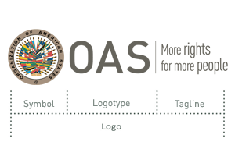
Source: http://www.oas.org/en/about/logo_elements.asp
The logo consists of three basic elements:
- Symbol – the graphic part.
- Logotype - usually the name of the company or product presented in an attractive way.
- Tagline - the company slogan in text form.
Our logo should be prepared in a variety of colours (the most common variants are: coloured, only black, only white, monochrome). The logo should be prepared in vector graphics (allowing for any enlargement of the graphics without losing quality) or be of high quality in the case of raster graphics (in which zooming in may cause the appearance of individual pixels, which will adversely affect the reception of the graphics – there is more information on both types of graphics in Chapter 6). It is good to also have them in various file formats, e.g. PNG, PDF, SVG. Logo files should be without any background.
Brand book - if we would like to take a precise approach to the issue of visual identification, it is worth thinking about the so-called brand book. This is a collection of all of the rules for creating materials for our chosen venture, the brand. The book contains, among others, information on such issues as the acceptable colouring, the principles of using and incorporating the logo into materials and the types of fonts used. The brand book - although undoubtedly recommended - is not an indispensable element of any activity, including cultural activity. However, it is worth knowing about it, especially when a graphic designer from an external company asks you if you have it.
- Graphics from the Internet
Sometimes we will use the vast resources of the Internet. Before we do, however, we must realize that not all materials published in this medium are completely at our disposal. Although awareness of copyright on the Internet is increasing, many users still treat it dismissively. However, respecting the rights of creators in the digital world is just as important as it is in the material world!
You may be held liable for abuse if you violate copyright laws. This is not a very common situation; however, respect for copyright should stem primarily not from the fear of punishment, but from respect for the creators and their work. It is worth remembering that the Internet is full of sources that allow use of graphics or photos for free. That is why it is worth getting to know such issues as the sources of paid and free materials, copyrights based on Creative Commons licenses and Google tools that make it easier to search for files that we can use.
There are, among others, pictures from paid and free services. In paid services, for a certain amount it is possible to download a photo for use in information posted on a site. After purchasing graphics, you can modify them and use them repeatedly without the need to have their use signed off.
The second option is to use free image aggregators, i.e. websites that collect photographs and graphics in one place, which can then be used free of charge to promote your own projects. In this case, you should pay attention to the license on the basis of which the photo is offered and comply with it. In most cases, photos from free sites are made available under a Creative Commons license, which allows sharing of content under certain conditions. Some of the sites offering free photos, e.g. Pixabay.com, require attribution of the source from which the image is taken.
Also in the case of placing photographs, the name and surname of the author should be given each time. The use of a photo without the consent and knowledge of the author may be associated with financial and legal consequences.
But what are Creative Commons licenses? They allow free use of the work in a certain defined scope, without the need to each time, individually, agree the conditions with the creator of the content.

Table 1. The four conditions of a Creative Commons license

Source: http://inspiratorzy.edumobile.pl/index.php/107-aktualnosci/303-warto-stosowac-licencje-cc
Creative Commons licenses exist as a combination of these 4 conditions. They define the possibilities and scope of using graphics and photos found on the Internet. Their detailed breakdown is presented in Table 2.

Table 2. Table of different Creative Commons license variants

Source: own elaboration based on http://inspiratorzy.edumobile.pl/index.php/107-aktualnosci/303-warto-stosowac-licencje-cc
Examples of graphics and photo aggregators that make materials available under a Creative Commons license:
- Pexels.com
- Pixabay.com
- Unsplash.com
- gratisography.com
- lifeofpix.com
- startupstockphotos.com
In search of graphics based on Creative Commons licenses, the Google search option can also be used. By going to its "Graphics" tab, we can choose the "Tools" option, and from there go to "Usage rights". Here we will see a drop-down list to choose from (see Figure 8):
- Not filtered by license,
- Labelled for reuse with modification,
- Labelled for reuse,
- Labelled for non-commercial reuse with modification,
- Labelled for non-commercial reuse.
As we can see, the above options (except the first one) are based on Creative Commons licenses.

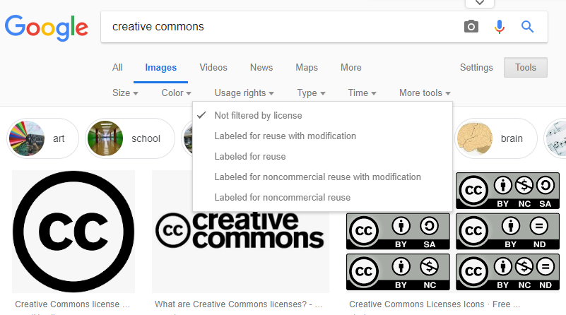
Figure 8. Google tool that allows searches for images under a Creative Commons license
Source: own work
When searching for images for reuse, we should remember one important thing: only the images displayed on the main page are covered by the selected license, while the images displayed in the preview in the "related images" field MAY BE SUBJECT TO ANOTHER LICENSE!
Figure 9. Related Images may be subject to another license
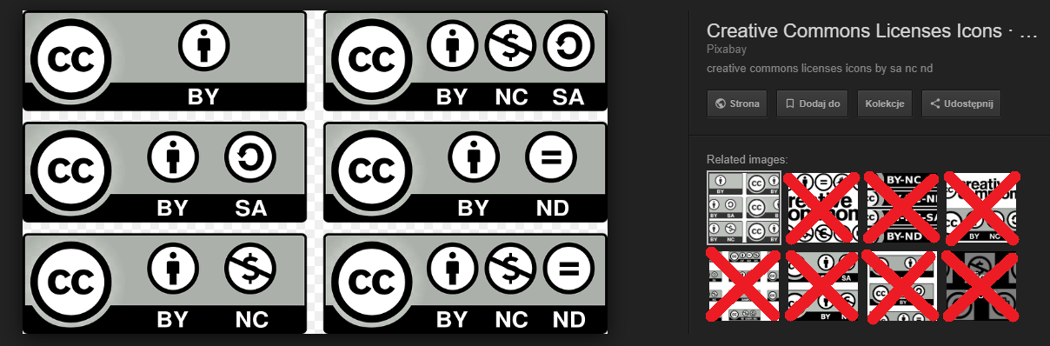
Source: own work
To sum up: although the Internet is not a source of materials that is unlimited in terms of copyright, it contains a lot of possibilities and free content which, if skilfully searched, can help us to prepare our own promotional materials.

- Summary
Even the most interesting events will not attract many customers if they are not properly promoted. That is why it is so important to be aware of the existing ways of getting your message across, which will allow us to inform people about our actions. By not taking such actions, we may waste the potential of the work we have created.
The issues presented in this part of the training materials form a good basis for the preparation of effective marketing communication, which promotional materials are an important part of. In order to achieve the best results, we must, of course, remember the most important principles of composition, choose the means that will allow us to reach our recipients directly and prepare attractive content that will stand out from other messages.
We cannot forget about the logo - the most basic element of visual communication. It is not without reason that large brands care about their recognition. It is important that the creators of culture also take care of it, which in this case means not only choosing a logo design that will be the most attractive and functional, but also activities aimed at ensuring its frequent exposure. We should remember to make our logo appear as often as possible, especially on all of the promotional materials we create.
Finally, it is worth recalling that the Internet, which is an almost infinite source of materials and inspiration, can come to our aid. However, using its resources it is necessary to respect copyright, and above all know how to use the work of authors that is made available for free.
The use of the knowledge provided in the training materials will allow you to promote your creativity more effectively. First, it is necessary to reach the recipient's awareness and persuade him to become acquainted with our cultural offer - the rest depends on the quality of the work that we will present.
- Further information
- Cooperation with a graphic designer
Not everyone is able to design and create promotional materials by themselves, which is why most often there is a need to decide on working with a graphic designer. If you will not prepare graphic materials yourself, but only supervise their creation, understanding the perspective of the person designing them will help in mutual communication, and hence – this will make the implementation of your vision in the form that you expect more effective and faster. In order for such cooperation to run smoothly and have satisfactory effects, one must at least partially understand the basics of computer graphics work and the limitations sometimes associated with it. Knowledge of basic concepts such as raster and vector graphics, understanding of colour matching rules and fonts as well as knowledge of the use of particular file formats will be useful. The most important information on these issues can be found in this part of the training materials.
But let's start with the basics. If someone has never dealt with custom design (not only graphics, but also, among others, websites, programming and many other fields), then they may not know what problems such a creator faces. Therefore, our ideas about the work of graphic designers - as often happens in such cases - may not match the reality. The creative process is difficult: problems may arise with a lack of a vision, inspiration and focus that may be influenced by, for example, an unfavourable environment.
Figure 10. Graphic designers’ work - expectations and reality
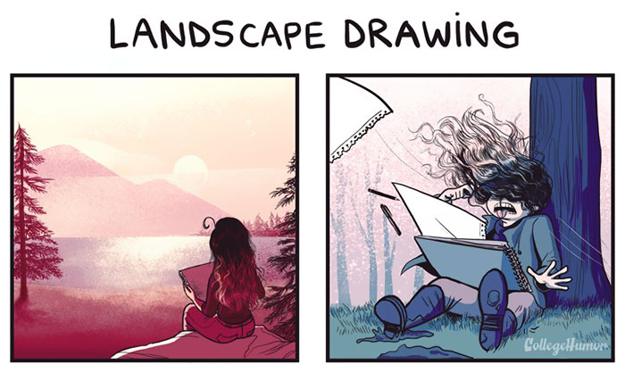
Source:https://www.boredpanda.com/drawing-courses-expectations-vs-reality/?utm_source=google&utm
_medium=organic&utm_campaign=organic
Contrary to popular belief, the greatest difficulty in working with graphics is therefore not practical mastering of programs. In the era of widely available online courses and tutorials, we can quickly find the right content that will help us perform even what seems to be a very complicated task. It is also not about a creative block which, although it sometimes happens and can make life difficult, can be overcome by means of appropriate techniques, inspiration or exposure to appropriate stimuli. After all, the creation of graphics is done by people who are creative, so when necessary they deal with such problems. Both of these issues - practical skills and stimulating creativity - depend only on the graphic designer and his methods of work. However, there is one thing that the creator is co-responsible for and cannot completely control. Therefore, when talking about the biggest problems, a frequent theme that comes up in the environment of designers is the relationship between the creator and the client.
Figure 11. Graphic designers’ problems with clients
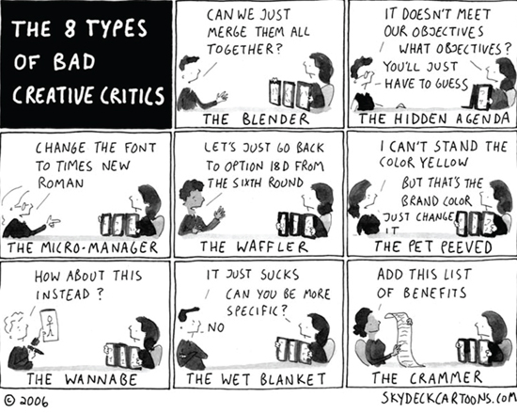
Source: https://graphiccave.com/funny-design-jokes-only-designers-can-relate-to/
When working with a graphic designer, we should remember how important proper communication is. In order for us to receive a satisfactory design, we must present the creator with as much detail as possible. We cannot leave him with a general outline of the material and ask: "Make it look great!". No graphic designer will be able to guess on that basis what we really want and what our vision of the material is. Therefore, when working with a graphic designer, remember to provide as much detail as possible and materials that can be used as inspiration or in the graphics.

Figure 12. Basic principles of cooperation with computer graphic designers

Source: own work
Lack of proper communication between the creator and the client may cause the vision to be missed, which requires a change in the concept and sometimes a complete remodelling of the design, i.e. the preparation of the material from the very beginning. This costs time and a good deal of trouble on both sides, which is why it is so important to precisely define your expectations in order to avoid such situations.
Of course, changes, corrections and alterations will appear in almost every design. It is impossible to fully convey a vision to a graphic designer, who, moreover, may prefer other solutions that will not necessarily suit us. In the meantime, other concepts and ideas may also appear, although it would be good if they did not involve a complete rejection of the original vision. Besides that, in the end everything can be improved! There are many reasons why we will work on the material together with the graphic designer. It is important, however, that these proportions (the work of the graphic designer and the customer's comments) should not be interfered with, as can be seen in Figure 13. If this happens, then either we are unable to convey our vision well or we are constantly changing the concept, or we have found a graphic designer who is not very competent.

Figure 13. Alterations are an inseparable element of every design
Source: https://graphiccave.com/funny-design-jokes-only-designers-can-relate-to/
We should also remember to use common sense. If we want to receive excellent graphics right away, then we have to accept the fact that we will have to pay much more. If we insist on it being fast and cheap, it is highly likely that the graphics will not be of adequate quality. You have to appreciate the graphic designer’s work and understand some limitations, keeping in mind the other issues covered in this chapter.
If we do not follow the recommendations in this chapter, there may be a situation where the final result of the graphic designer’s work will be far from what we expect. Therefore, effective communication is the key to successful cooperation with a computer graphic designer. However, in this area good intentions are not enough, we must also find a common language and use concepts that operate in this environment.
Figure 14. The difference between customer expectations and graphic designers’ implementation
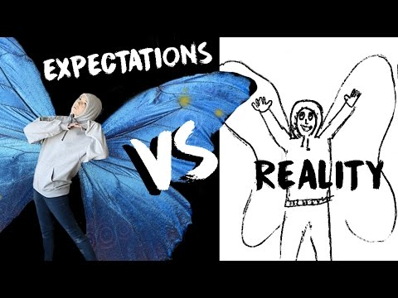
Source: https://www.youtube.com/watch?v=a5uM1j95TVA
Therefore, even if you will not deal with advanced graphic design, you should learn the basics regarding the specificity and technical aspects of the entire process of creating visual material. This will enable easier contact with the creator of graphics and presentation of your vision to him. The most important issues in this field will be presented in the next chapters.
- Types of graphics and file formats
The first and basic technical issue that helps to understand the principles and limitations associated with graphic design is the existence of two types of graphics. Each of them has its advantages and disadvantages as well as its own application. These two types of graphics are:
- Raster graphics - a form of presentation and manipulation of images created with the help of individual pixels. It is used for complex images using a wide range of colours (e.g. photographs).
- Vector graphics - a form of presentation and manipulation of images created using mathematical vectors and simple planes. Vector images are characterized by simplicity, and their main advantage is lossless scaling, which is why vector graphics are used when creating diagrams, graphs or technical drawings that do not require many details.
The specificity of the differences between these two types of graphics is presented in Figure 15. It shows what the scalability issue looks like in the case of raster graphics and vector graphics.
Figure 15. A comparison of the brushes used in raster and vector graphics
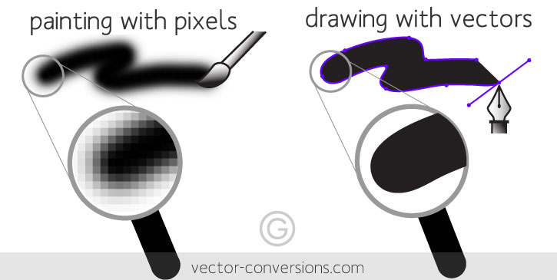
Source: https://vector-conversions.com/vectorizing/raster_vs_vector.html
Do not let the first impression fool you. Figure 15 does not indicate that vector graphics overshadow raster. Vector graphics cannot cope with multi-colour display and too much detail, so they are not suitable as a format for saving realistic photos. The possibility of free scaling of vector graphics without losing quality is paid for by simplifying the whole picture, which is perfectly illustrated in Figure 16.
Figure 16. Picture saved in raster and vector graphics
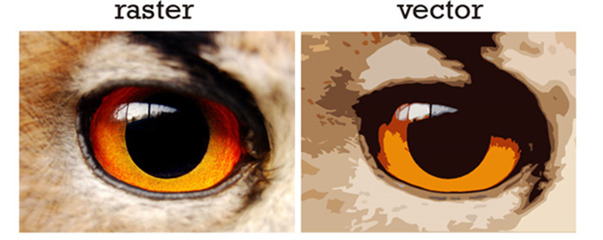
Source: https://olypress.com/vector-vs-raster-graphics-in-printing/
In fact, it is impossible to clearly indicate which of these types of graphics is better, because each serves a different purpose. Therefore, when creating our vision, the implementation of which we will commission to a graphic designer, we need to know what is important to us and what exactly we want to achieve, and to be aware of certain technical limitations. Details of both types of graphics are shown in Table 3.
Table 3. Advantages, disadvantages and the use of raster graphics and vector graphics
 | Advantages | Disadvantages | Use
Vector graphics | Graphics can be scaled to any size,  Parameters and attributes of objects are remembered (free transformations like scaling, rotation and filling with colour do not degrade the image quality),  Images require a small amount of information, which means they take up less space on a hard disk,  Lossless quality (smooth edges of shapes and proportionally preserved thickness of curves after approximation),  The format is adaptively optimized for display devices (e.g. mobile),  Good conversion to raster graphics. | Shading is not as detailed as in raster files,  Large memory complexity for photorealistic images (a need for an efficient processor to generate visual information from the algorithm and vectorization),  Some file formats require special software for viewing/displaying,  Unsuitable for showing a lot of details. | Logotypes,  Material for printing,  Infographics,  Flags, coats of arms and emblems,  Maps and plans,  Advertising billboards,  Business cards,  Road and information  signs  Comics,  Illustrations,  Typography,  Flash animations.
Raster graphics | Incredible gradient effects and display of shadows,  Wealth and depth of colour, contrast, brightness and saturation,  Popular file types,  The possibility of using complex tools for processing digital photographs,  The possibility of retouching, correction, various forms of editing (photomontage). | Large file sizes,  Loss of quality during zooming in,  No possibility of conversion to vectors. | Photography,  Realistic paintings,  Graphics from/in the network,  Screen graphics (TV, DVD)  Advertising documents and leaflets.
Source: elaboration based on https://artixen.net/roznice-miedzy-grafika-wektorowa-a-rastrowa/
Open files - each professionally prepared graphic is compiled in so-called open files. These are graphic design files, where all the elements and parameters of the image that can be freely modified are recorded in detail. It is sometimes worth asking for a graphic designer to provide an open file if in the future we want to easily change the design for the next activities. Raster graphics are usually prepared in Adobe Photoshop and Gimp, and vector in Adobe Illustrator and Corel Draw.
Standard graphics files are used for everyday use and printing. Their basic formats are (raster graphics):
- JPG,
- PNG,
- GIF,
- TIFF.
The basic graphics file formats (vector graphics) are:
- SVG,
- EPS,
- SWF.
- Colours
Another important issue regarding the work of computer graphic designers are colours. However, this not only regards their proper selection and composition. This problem is more complex and is related to the way a computer displays colours. A general understanding of this issue will allow us to communicate better with the graphic designer.
Contemporary computer graphics allow you to obtain many different shades of colours. All of them, however, are a derivative of the mixing of the so-called basic colours in appropriate proportions. There are two main colour palettes in graphics:
- RGB - the palette consists of 3 primary colours: red (R), green (G) and blue (B). This mode is used to record and represent colours on monitor screens.
- CMYK - the palette consists of 4 basic colours: cyan (C), magenta (M), yellow (Y) and black (K). This mode is used for colours intended for printing.
Colours from CMYK mode are characterized by lower intensity than those from RGB mode, in addition, the RGB colour range is wider.
"The conclusions are, above all, that the assessment of a design on a screen must include an awareness that the print will have much more suppressed colours and contrast, and it is important that when converting RGB to CMYK we cannot avoid the colours changing a little. We must simply reconcile with this fact and/or keep it in mind.
It is also an important conclusion that not every graphics program (especially free) is suitable for preparing documents for printing. For example, the wonderful free graphical tool that is GIMP does not have a CMYK space implemented (...).
Final conclusion. What should we do when it is absolutely necessary to check how the design will look before we print 10,000 copies of leaflets? The answer is a so-called proof. This is a test print that we can order from a printing house so that we can see and decide whether this quality will be satisfactory for us with a large expenditure. Naturally, a proof is more troublesome and for additional payment".
Figure 17. The two basic colour palettes in CMYK and RGB modes
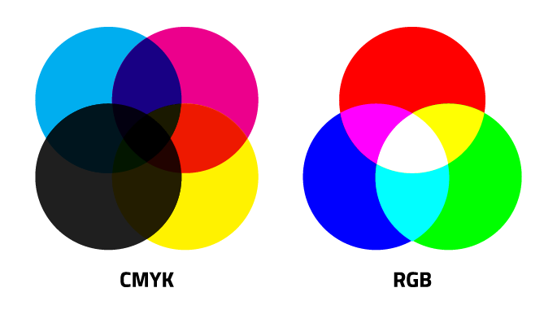
Source: https://trillioncreative.com/difference-between-cmyk-and-rgb/
You do not need to be familiar with the detailed specifications and nature of each colour mode. It is the graphic designer who must know this. However, in order for the cooperation to work well, you need to remember what mode he used when designing the material for printing or put him in contact with the printer who the material will then go to, so that he can get all the necessary information from the source.
Principles of choosing colours - above all, the colours should pertain to the colour scheme of your business. Consistent visual identification relies on the use of a constant colour combination, which facilitates the connection of our message with what we do (the colours selected are used in the logo, on promotional materials, in buildings, in the costumes of performing artists, etc.).
When choosing the dominant colours for our communication it is worth remembering that their meaning and associations are not a universal but a cultural issue. While in most Western countries the colour of mourning is black, for example in Japan, sadness after the loss of a loved one is symbolised by red.

Figure 18. Meanings and associations of the most popular colours

Source: developed on the basis of https://edugrafia.pl/jak-stosowac-kolory-w-reklamach-bannerowych/
Choosing colours is neither easy nor obvious. Like any creative activity, it eludes simple schemes. Even the general associations presented in Figure 18 are not a simple recipe for effective colour matching. One can point out many exceptions, for example, in the case of a creative activity, which as the name suggests, is creative by nature, should we necessarily emphasize this feature by using orange colour?
Much also depends on what effect we want to achieve. If we are organising a serious evening poem recital, black could be a good choice. We do a dance that is full of passion? Let's go for red. When our work is characterized by minimalism - white will turn out to be the right colour.
In fact, in the case of artistic activity, matching colours is particularly difficult. In the end, it is a creative activity, where what counts is creativity, breaking patterns, and distinguishing yourself through remarkable combinations. This means that even colours that generally do not fit into creative activity, such as brown or green, can find a place in visual identification. The most important thing is that the colours chosen should be consistent with all our other activities, harmoniously dovetailed with our entire vision.
However, if you would prefer some help that would automate the combination of colours in a certain way, you can always use ready-made tools, such as:
- Paletton
- Color.hailpixel
- Colorhunt
- Colorfulgradients.tumblr
- Brandcolors
- Colordrop.io
- Coolors.co
- Color-hex
- Color.adobe
- Colourlovers
- Materialpalette
- Flatuicolors
- Colorsafe.co
- Colorsupplyyy
- Colourco
- Labs.tineye
- Palettable.io
- Canva.com/color-palette
- Colorfavs
- Colrd
- Fonts
When dealing with visual coherence and the preparation of promotional materials, attention should be paid not only to the colours chosen but also to the fonts used. It is worth knowing that individual typefaces have their use in printing, and others on computer displays, while the shape of individual letters can affect even the reception of the message.
The fonts are divided into two basic types:
- Sans-serif - characterized by simplicity and a lack of additional frills. These fonts are especially popular on the Internet (and in electronic documents), where, due to the specificity of screens and scalability (i.e. zooming in and out of the image), they are better suited for displaying content.
- Serif - used primarily in print, where they are easier to read (unlike on a monitor), and because of their elegance and ornamentation, these fonts are also useful to emphasize the aesthetic side of a written text.
Figure 19. Comparison of the letter "F" in serif type (left) and sans-serif (right)
Source: https://www.fonts.com/content/learning/fontology/level-1/type-anatomy/serif-vs-sans-for-text-in-print
Figure 19 shows the difference between serif and sans-serif fonts. It is related to the occurrence (or not) of the so-called serifs, which are additional ornamentation of letters.
Examples of sans-serif fonts:
- Arial,
- Verdana,
- Trebuchet MS,
- Helvetica,
- Univers,
- Futura.
Examples of serif fonts:
- Times New Roman,
- Garamond,
- Georgia,
- Palatino.
Although it may seem surprising, the font may also sometimes affect the reception of the content. Properly selected, it can emphasize the character of the message being read, give it weight or, on the contrary, a characteristic lightness. The influence of the typeface on the reception of the reading content is well illustrated in Figure 20.
Figure 20. The font type affects the reception of the message
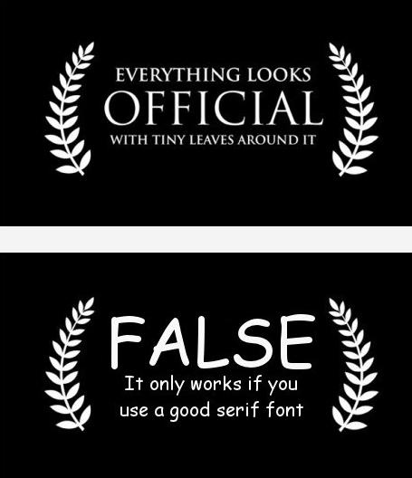
Source: https://graphiccave.com/funny-design-jokes-only-designers-can-relate-to/
To take care of the visual coherence of the materials being prepared, you should consistently use the same fonts. It is recommended to set a main font and an auxiliary font, which will be an alternative. Main fonts should be used consistently: in Word documents, on a website. Sometimes selected fonts will look bad on designs intended for printing - in this case, it may be justifiable to choose a different font. In this case, there is one important rule: printed material should not use many typefaces or complicated fonts. The use of one kind will help to preserve the transparency and aesthetics of the design.
It is worth remembering one more thing: there is an opinion in the graphic designers' community that a certain font indicates an evident lack of taste. It is Comic Sans, which is used to write texts inside speech bubbles in comics. It contains that comic lightness - but for people dealing with graphics, the font is too characteristic, which makes it generally unsuitable for using outside the domain of graphic stories. Of course, this point does not have the status of a revealed truth, but rather an unwritten rule of the environment of graphic designers. Despite this, it is worth knowing about it, so as not to get into our graphic designer’s bad books at the outset.
Figure 21. Comic Sans font is not popular in the graphic designer community
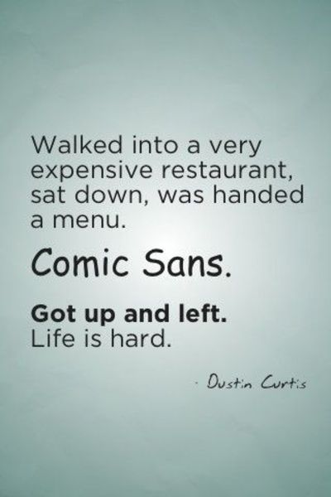
Source: https://graphiccave.com/funny-design-jokes-only-designers-can-relate-to/
Using the highest quality graphics and promotional materials is an effective way to attract the attention of recipients. Before we begin to get into the content, the form has to interest us - in addition, even substantively valuable content can lose something when it is not properly presented. That is why we should care about the materials we use being of the appropriate aesthetic level.
If we do not have graphics skills, we must rely on working with a graphic designer. Such cooperation is not just about commissioning a design - we also have to be able to artfully present our vision (the more detailed the better), consult on the progress of the work, and submit corrections. To effectively communicate with the graphic designer, well-developed soft skills are not enough (though they are very useful), but we will also need knowledge about technical issues related to graphic design. Knowledge of the terms will facilitate the formulation of the message and understanding the principles of computer graphics will help us to find a common language and avoid mutual misunderstandings.
First of all, it is necessary to remember about the disadvantages, advantages and applications of particular types of computer graphics. It is also a good idea to ask for designs to be sent in a variety of file formats - you never know when a file saved with another extension will be useful. Knowledge about matching colours and fonts will allow us to indicate the direction in which the graphics should be created and formulate substantive remarks.
Skilful application of the principles contained in these training materials and good communication with a computer graphic designer should provide us with high-quality promotional materials. Ones that will be both functional and aesthetic, thus ensuring us the most effective reach to a wide audience.

- Bibliography
- 50 brilliant billboard ads that will stop you in your tracks (and what you can learn from them), https://www.canva.com/learn/billboard-advertising/
- Cool Blue. Brand guidelines template, https://www.behance.net/gallery/26216169/Free-Brand-Book-Template-Cool-Blue
- Dawid Kotwin, Why do advertising materials look different on the screen and in print? RGB and CMYK, http://www.artekot.com/materialy-reklamowe/
- Emilia Wójcik, How to design a good poster, https://emiliawojcik.pl/blog/jak-zaprojektowac-dobry-plakat/
- Eugen Eşanu, Product Design: Expectations vs Reality, https://uxplanet.org/product-design-expectations-vs-reality-2e5b24473dc5
- Fabrizio De Luca, https://www.behance.net/gallery/6314037/Architect-Business-Card
- Foto de archivo - Guitarra, estilo realista diseño del instrumento musical y la música del cartel A4 diseño festival para vector comercial. instrumento musical y el concepto de música, https://es.123rf.com/photo_61469363_guitarra-estilo-realista-dise%C3%B1o-del-instrumento-musical-y-la-m%C3%BAsica-del-cartel-a4-dise%C3%B1o-festival-para-vector-.html
- Funny design jokes only designers can relate to, https://graphiccave.com/funny-design-jokes-only-designers-can-relate-to/
- https://vector-conversions.com/vectorizing/raster_vs_vector.html
- Ilene Strizver, Serif vs. Sans for Text in Print, https://www.fonts.com/content/learning/fontology/level-1/type-anatomy/serif-vs-sans-for-text-in-print
- How to design a good billboard, http://imagine-x.pl/blog/jak-zaprojektowac-dobry-billboard/
- James Gould-Bourn, Expectation Vs Reality Of Drawing Courses, https://www.boredpanda.com/drawing-courses-expectations-vs-reality/?utm_source=google&utm
_medium=organic&utm_campaign=organic
- Logo Elements, http://www.oas.org/en/about/logo_elements.asp
- Lou Leonardis, Hey Lou, What’s the Difference Between CMYK and RGB?, https://trillioncreative.com/difference-between-cmyk-and-rgb/
- Krzysztof Małota, It is worth using Creative Commons licenses, http://inspiratorzy.edumobile.pl/index.php/107-aktualnosci/303-warto-stosowac-licencje-cc
- Rafał Wróbel, How to apply colours in banner ads, https://edugrafia.pl/jak-stosowac-kolory-w-reklamach-bannerowych/
- Robin Sealark, Expectations VS Reality | ART, https://www.youtube.com/watch?v=a5uM1j95TVA
- The differences between raster and vector graphics, https://artixen.net/roznice-miedzy-grafika-wektorowa-a-rastrowa/
- Shaun Cleary, The Periodic Table of Print Design: Leaflet Edition, https://www.fastprint.co.uk/blog/the-periodic-table-of-print-design-leaflet-edition.html
- Star Wars R2-D2 USB Car Charger, https://www.thinkgeek.com/product/11f0/
- The Power of Paper, https://www.letterboxdistribution.com/the-power-of-paper/
- Thomas Huthwaite, Some rights reserved: Creative Commons and the new era of copyright, https://www.baldwins.com/news/some-rights-reserved-creative-commons-and-the-new-era-of-copyright
- Vector & Raster Graphics in Offset Printing, https://olypress.com/vector-vs-raster-graphics-in-printing/
- What is a Creative Commons (CC) Licence?, http://discourse.col.org/t/what-is-a-creative-commons-cc-licence/61
- What makes up a logo?, http://dfinebranding.com/what-makes-up-a-logo/
- A perfect business card - what is it?, https://www.viperprint.pl/oryginalna-wizytowka
- Wojciech Wesołowski, 7 tips that will help you design an effective roll-up banner, https://powiemto.pl/7-rad-ktore-pozwola-zaprojektowac-skuteczny-roll-up/

A perfect business card - what is it?, https://www.viperprint.pl/oryginalna-wizytowka, on 19.12.2018.
71 Elegant, Personable, Artists Business Card Designs, https://businesscard.designcrowd.com/contest/2384174, on 11.01.2019.
The Power of Paper, https://www.letterboxdistribution.com/the-power-of-paper/, on 19.12.2018.
The Power of Paper, https://www.letterboxdistribution.com/the-power-of-paper/, on 19.12.2018.
Emilia Wójcik, How to design a good poster, https://emiliawojcik.pl/blog/jak-zaprojektowac-dobry-plakat/, on 18.12.2018.
Foto de archivo - Guitarra, estilo realista diseño del instrumento musical y la música del cartel A4 diseño festival para vector comercial. instrumento musical y el concepto de música, https://es.123rf.com/photo_61469363_guitarra-estilo-realista-dise%C3%B1o-del-instrumento-musical-y-la-m%C3%BAsica-del-cartel-a4-dise%C3%B1o-festival-para-vector-.html, on 19.12.2018.
How to design a good billboard, http://imagine-x.pl/blog/jak-zaprojektowac-dobry-billboard/, on 19.12.2018.
50 brilliant billboard ads that will stop you in your tracks (and what you can learn from them), https://www.canva.com/learn/billboard-advertising/, on 19.12.2018.
Wojciech Wesołowski, 7 tips that will help you design an effective roll up, https://powiemto.pl/7-rad-ktore-pozwola-zaprojektowac-skuteczny-roll-up/, on 11.01.2019.
Star Wars R2-D2 USB Car Charger, https://www.thinkgeek.com/product/11f0/, on 11.01.2019.
Logo Elements, http://www.oas.org/en/about/logo_elements.asp, on 18.12.2018.
What makes up a logo?, http://dfinebranding.com/what-makes-up-a-logo/, on 18.12.2018.
UMW Report, May 2016, p. 15.
Krzysztof Małota, It is worth using Creative Commons licenses, http://inspiratorzy.edumobile.pl/index.php/107-aktualnosci/303-warto-stosowac-licencje-cc, on 18.12.2018.
Krzysztof Małota, It is worth using Creative Commons licenses, http://inspiratorzy.edumobile.pl/index.php/107-aktualnosci/303-warto-stosowac-licencje-cc, on 18.12.2018.
James Gould-Bourn, Expectation Vs Reality Of Drawing Courses, https://www.boredpanda.com/drawing-courses-expectations-vs-reality/?utm_source=google&utm_medium=organic&utm_campaign=organic, on 18.12.2018.
Funny design jokes only designers can relate to, https://graphiccave.com/funny-design-jokes-only-designers-can-relate-to/, on 18.12.2018.
Funny design jokes only designers can relate to, https://graphiccave.com/funny-design-jokes-only-designers-can-relate-to/, on 18.12.2018.
Robin Sealark, Expectations VS Reality | ART, https://www.youtube.com/watch?v=a5uM1j95TVA, on 18.12.2018.
https://vector-conversions.com/vectorizing/raster_vs_vector.html, on 18.12.2018.
Vector & Raster Graphics in Offset Printing, https://olypress.com/vector-vs-raster-graphics-in-printing/, on 18.12.2018.
The differences between raster and vector graphics, https://artixen.net/roznice-miedzy-grafika-wektorowa-a-rastrowa/, on 18.12.2018.
Dawid Kotwin, Why do advertising materials look different on the screen and in print? RGB and CMYK, http://www.artekot.com/materialy-reklamowe/, on 18.12.2018.
Lou Leonardis, Hey Lou, What’s the Difference Between CMYK and RGB?, https://trillioncreative.com/difference-between-cmyk-and-rgb/, on 18.12.2018.
Rafal Wróbel, How to apply colors in banner ads, https://edugrafia.pl/jak-stosowac-kolory-w-reklamach-bannerowych/, on 18.12.2018.
Ilene Strizver, Serif vs. Sans for Text in Print, https://www.fonts.com/content/learning/fontology/level-1/type-anatomy/serif-vs-sans-for-text-in-print, on 11.01.2019.
Funny design jokes only designers can relate to, https://graphiccave.com/funny-design-jokes-only-designers-can-relate-to/, on 18.12.2018.
Funny design jokes only designers can relate to, https://graphiccave.com/funny-design-jokes-only-designers-can-relate-to/, on 18.12.2018.

